Scientific Investigations
Day 8: Lesson Quiz
Choose the letter of the best answer.

1. Juan hypothesizes that some birds fly south to locations with warmer weather and blooming flowers during the winter months. Which procedure should Juan use to test his hypothesis?
A. Survey northern and southern residents about the birds in their areas.
B. Observe the direction the birds fly when they depart in the winter.
C. Tag the birds with transmitters and track their movement.
D. Set up observation posts in the south to verify the time of year that birds arrive.
2. Scientific investigations include many different steps. After which step in a scientific investigation might a scientist use results to reject an existing hypothesis and form a new hypothesis?
A. Analyze data.
B. Identify variables.
C. Follow a procedure.
D. Review safety practices.
3. In chemistry, scientists classify some elements as metals. Which property of the metal copper can a scientist identify through observation alone?
A. Its density is 8.96 g/cm³.
B. It is a good conductor of heat.
C. It has a low electrical resistance.
D. It has a metallic, golden-brown color.
4. Why might a scientist choose to do fieldwork instead of a laboratory experiment?
A. She needs a large amount of control.
B. He needs to change one or more variables at a time.
C. She needs to observe organisms under natural conditions.
D. He needs to make exact measurements using large equipment.
5. Shakira hypothesizes that hot objects cool at constant rates. She experiments by heating a metal object with a Bunsen burner and then allowing it to cool to room temperature. She records her results in a graph.
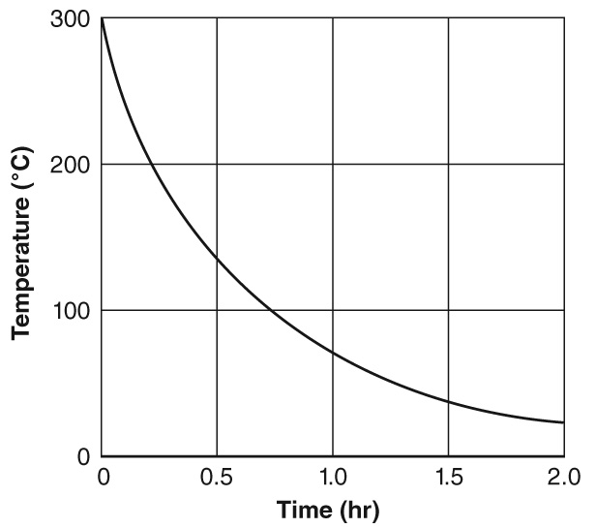
Which choice describes the results of the experiment and tells what Shakira should do next?
A. The result of the experiment is not conclusive. Shakira should repeat the experiment.
B. The downward curve supports the hypothesis. Shakira should present her results to the class.
C. The graph supports the hypothesis. Shakira should conduct several more trials to increase the accuracy of her data.
D. The graph does not support the original hypothesis. Shakira should revise the hypothesis and design a new experiment.

